Name: Sufyan Afzal
Reg No: FA23-BAI-061

Lab Assignment 2 - ANN & DL

Task 1
Cell 2 — Import libraries and set random seeds
import numpy as np
import pandas as pd
import matplotlib.pyplot as plt
import tensorflow as tf
import time
from sklearn.datasets import load_iris
from sklearn.model_selection import train_test_split
from sklearn.preprocessing import StandardScaler
from sklearn.metrics import accuracy_score, classification_report, confusion_matrix, ConfusionMatrixDisplay
from tensorflow.keras import Sequential
from tensorflow.keras.layers import Dense, Dropout
from tensorflow.keras.regularizers import l1, l2
from tensorflow.keras.callbacks import EarlyStopping, LearningRateScheduler
np.random.seed(42)
tf.random.set_seed(42)
print("TensorFlow version:", tf.__version__)
print("NumPy version:", np.__version__)
print("Libraries imported successfully.")
TensorFlow version: 2.19.1
NumPy version: 1.26.4
Libraries imported successfully.
Cell 3 — Load the Iris dataset
iris = load_iris()
X = pd.DataFrame(iris.data, columns=iris.feature_names)
y = iris.target
df = X.copy()
df["species"] = [iris.target_names[i] for i in y]
print("Dataset shape:", df.shape)
print("Number of features:", X.shape[1])
print("Number of classes:", len(np.unique(y)))
print("Species:", list(iris.target_names))
print("\nFirst five rows:")
display(df.head())
print("\nMissing values:", df.isnull().sum().sum())
print("\nClass distribution:")
print(df["species"].value_counts())
Dataset shape: (150, 5)
Number of features: 4
Number of classes: 3
Species: ['setosa', 'versicolor', 'virginica']
First five rows:
Missing values: 0
Class distribution:
species
setosa 50
versicolor 50
virginica 50
Name: count, dtype: int64
Cell 4 — Visualize the dataset
fig, axes = plt.subplots(1, 2, figsize=(13, 5))
df["species"].value_counts().reindex(iris.target_names).plot(
kind="bar", ax=axes[0]
)
axes[0].set_title("Number of Samples per Species")
axes[0].set_xlabel("Species")
axes[0].set_ylabel("Number of Samples")
axes[0].tick_params(axis="x", rotation=0)
for species in iris.target_names:
subset = df[df["species"] == species]
axes[1].scatter(
subset["petal length (cm)"],
subset["petal width (cm)"],
label=species
)
axes[1].set_title("Petal Measurements by Species")
axes[1].set_xlabel("Petal Length (cm)")
axes[1].set_ylabel("Petal Width (cm)")
axes[1].legend()
plt.tight_layout()
plt.show()
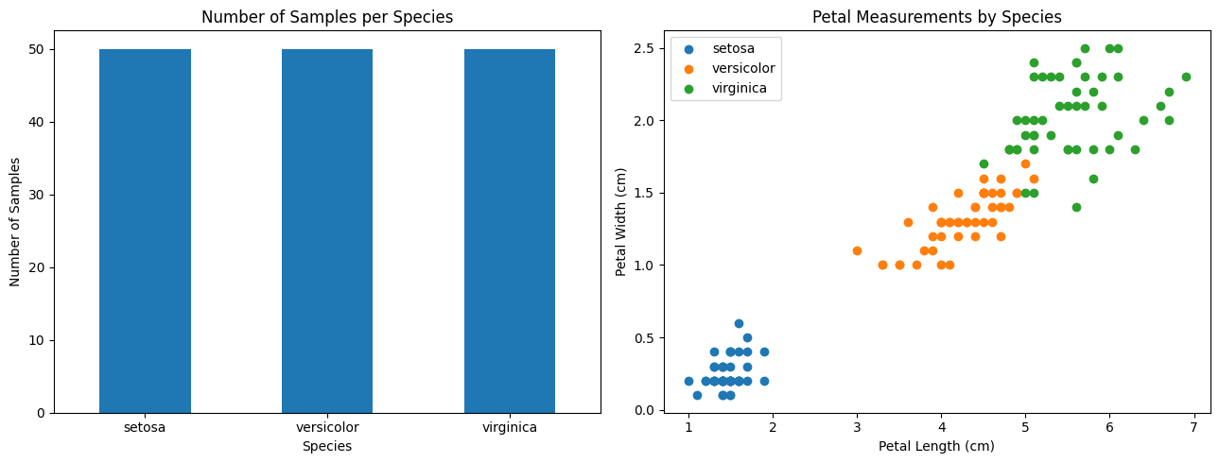
Cell 5 — Split into training, validation and testing sets
X_train_raw, X_temp_raw, y_train, y_temp = train_test_split(
X, y, test_size=0.4, random_state=42, stratify=y
)
X_val_raw, X_test_raw, y_val, y_test = train_test_split(
X_temp_raw, y_temp, test_size=0.5, random_state=42, stratify=y_temp
)
split_summary = pd.DataFrame({
"Dataset": ["Training", "Validation", "Testing"],
"Samples": [len(y_train), len(y_val), len(y_test)],
"Percentage": [
len(y_train) / len(y) * 100,
len(y_val) / len(y) * 100,
len(y_test) / len(y) * 100
]
})
display(split_summary)
print("Training class counts:", np.bincount(y_train))
print("Validation class counts:", np.bincount(y_val))
print("Testing class counts:", np.bincount(y_test))
Training class counts: [30 30 30]
Validation class counts: [10 10 10]
Testing class counts: [10 10 10]
Cell 6 — Preprocess the data
scaler = StandardScaler()
X_train = scaler.fit_transform(X_train_raw)
X_val = scaler.transform(X_val_raw)
X_test = scaler.transform(X_test_raw)
scaled_summary = pd.DataFrame({
"Feature": iris.feature_names,
"Training Mean": X_train.mean(axis=0),
"Training Standard Deviation": X_train.std(axis=0)
})
display(scaled_summary.round(4))
fig, axes = plt.subplots(1, 2, figsize=(12, 4))
axes[0].boxplot(X_train_raw.values)
axes[0].set_title("Original Training Features")
axes[0].set_xlabel("Feature Index")
axes[0].set_ylabel("Measurement")
axes[1].boxplot(X_train)
axes[1].set_title("Standardized Training Features")
axes[1].set_xlabel("Feature Index")
axes[1].set_ylabel("Standardized Value")
plt.tight_layout()
plt.show()
print("Training shape:", X_train.shape)
print("Validation shape:", X_val.shape)
print("Testing shape:", X_test.shape)
print("Preprocessing completed.")
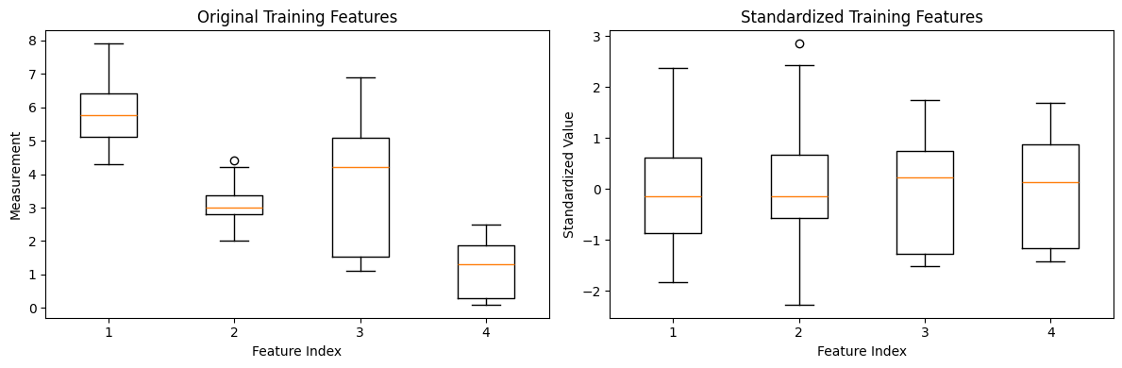
Training shape: (90, 4)
Validation shape: (30, 4)
Testing shape: (30, 4)
Preprocessing completed.
Cell 7 — Build the MLP model and training function
def build_model(initializer="he_normal", regularization=None, dropout_rate=0.0):
tf.keras.backend.clear_session()
if regularization == "l1":
regularizer = l1(0.001)
elif regularization == "l2":
regularizer = l2(0.001)
else:
regularizer = None
model = Sequential([
tf.keras.Input(shape=(X_train.shape[1],)),
Dense(16, activation="relu", kernel_initializer=initializer, kernel_regularizer=regularizer),
Dropout(dropout_rate),
Dense(8, activation="relu", kernel_initializer=initializer, kernel_regularizer=regularizer),
Dense(3, activation="softmax", kernel_initializer=initializer)
])
model.compile(
optimizer=tf.keras.optimizers.Adam(learning_rate=0.01),
loss="sparse_categorical_crossentropy",
metrics=["accuracy"]
)
return model
class LearningRateRecorder(tf.keras.callbacks.Callback):
def __init__(self):
super().__init__()
self.rates = []
def on_epoch_begin(self, epoch, logs=None):
self.rates.append(float(tf.keras.backend.get_value(self.model.optimizer.learning_rate)))
def train_model(initializer="he_normal", regularization=None, dropout_rate=0.0,
learning_rate_strategy="constant", batch_size=16, epochs=5,
early_stopping=False):
model = build_model(initializer, regularization, dropout_rate)
callbacks = []
if learning_rate_strategy == "exponential":
callbacks.append(
LearningRateScheduler(lambda epoch, lr: 0.01 * (0.8 ** epoch))
)
lr_recorder = LearningRateRecorder()
callbacks.append(lr_recorder)
if early_stopping:
callbacks.append(
EarlyStopping(
monitor="val_loss",
patience=5,
restore_best_weights=True
)
)
start = time.perf_counter()
history = model.fit(
X_train, y_train,
validation_data=(X_val, y_val),
epochs=epochs,
batch_size=batch_size,
callbacks=callbacks,
verbose=0
)
elapsed = time.perf_counter() - start
results = {
"model": model,
"history": history,
"learning_rates": lr_recorder.rates,
"training_time": elapsed,
"epochs_completed": len(history.history["loss"])
}
return results
print("MLP model and training function are ready.")
print("Input neurons:", X_train.shape[1])
print("Hidden layer neurons: 16 and 8")
print("Output neurons:", len(iris.target_names))
MLP model and training function are ready.
Input neurons: 4
Hidden layer neurons: 16 and 8
Output neurons: 3
Cell 8 — Requirement 2: Compare weight initialization
initialization_results = {}
for initializer in ["he_normal", "glorot_uniform"]:
initialization_results[initializer] = train_model(
initializer=initializer,
batch_size=16,
epochs=5
)
initialization_table = []
for name, result in initialization_results.items():
history = result["history"].history
initialization_table.append({
"Initialization": name,
"Epochs": result["epochs_completed"],
"Final Training Accuracy": history["accuracy"][-1],
"Final Validation Accuracy": history["val_accuracy"][-1],
"Final Training Loss": history["loss"][-1],
"Final Validation Loss": history["val_loss"][-1],
"Training Time (seconds)": result["training_time"]
})
initialization_df = pd.DataFrame(initialization_table)
display(initialization_df.round(4))
fig, axes = plt.subplots(1, 2, figsize=(12, 4))
for name, result in initialization_results.items():
h = result["history"].history
axes[0].plot(h["loss"], marker="o", label=name)
axes[1].plot(h["val_accuracy"], marker="o", label=name)
axes[0].set_title("Training Loss by Initialization")
axes[0].set_xlabel("Epoch")
axes[0].set_ylabel("Loss")
axes[1].set_title("Validation Accuracy by Initialization")
axes[1].set_xlabel("Epoch")
axes[1].set_ylabel("Accuracy")
axes[0].legend()
axes[1].legend()
plt.tight_layout()
plt.show()
print("He initialization is designed for ReLU activations.")
print("Glorot initialization balances the variance across layers.")
print("The table and plots show the observed results for this run.")
WARNING:tensorflow:From c:\Users\Omen\AppData\Local\Programs\Python\Python312\Lib\site-packages\keras\src\backend\common\global_state.py:82: The name tf.reset_default_graph is deprecated. Please use tf.compat.v1.reset_default_graph instead.
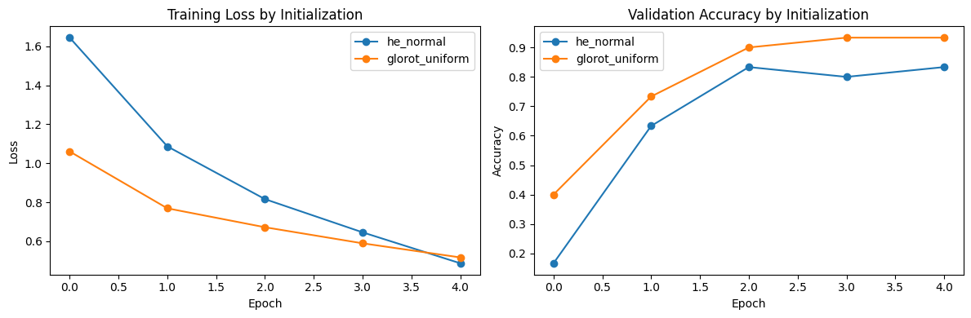
He initialization is designed for ReLU activations.
Glorot initialization balances the variance across layers.
The table and plots show the observed results for this run.
Cell 9 — Requirement 3: Compare learning-rate strategies
lr_results = {}
for strategy in ["constant", "exponential"]:
lr_results[strategy] = train_model(
initializer="he_normal",
learning_rate_strategy=strategy,
batch_size=16,
epochs=20
)
lr_table = []
for strategy, result in lr_results.items():
h = result["history"].history
lr_table.append({
"Strategy": strategy,
"Initial Learning Rate": result["learning_rates"][0],
"Final Learning Rate": result["learning_rates"][-1],
"Final Training Loss": h["loss"][-1],
"Final Validation Loss": h["val_loss"][-1],
"Final Validation Accuracy": h["val_accuracy"][-1],
"Training Time (seconds)": result["training_time"]
})
display(pd.DataFrame(lr_table).round(4))
fig, axes = plt.subplots(1, 3, figsize=(16, 4))
for strategy, result in lr_results.items():
h = result["history"].history
axes[0].plot(h["loss"], marker=".", label=strategy)
axes[1].plot(h["val_loss"], marker=".", label=strategy)
axes[2].plot(result["learning_rates"], marker="o", label=strategy)
axes[0].set_title("Training Loss")
axes[1].set_title("Validation Loss")
axes[2].set_title("Learning Rate by Epoch")
for ax in axes:
ax.set_xlabel("Epoch")
ax.legend()
axes[0].set_ylabel("Loss")
axes[1].set_ylabel("Loss")
axes[2].set_ylabel("Learning Rate")
plt.tight_layout()
plt.show()
print("Constant learning rate: the learning rate remains unchanged.")
print("Exponential schedule: the learning rate decreases after each epoch.")
print("Compare validation loss and accuracy to judge which strategy worked better.")
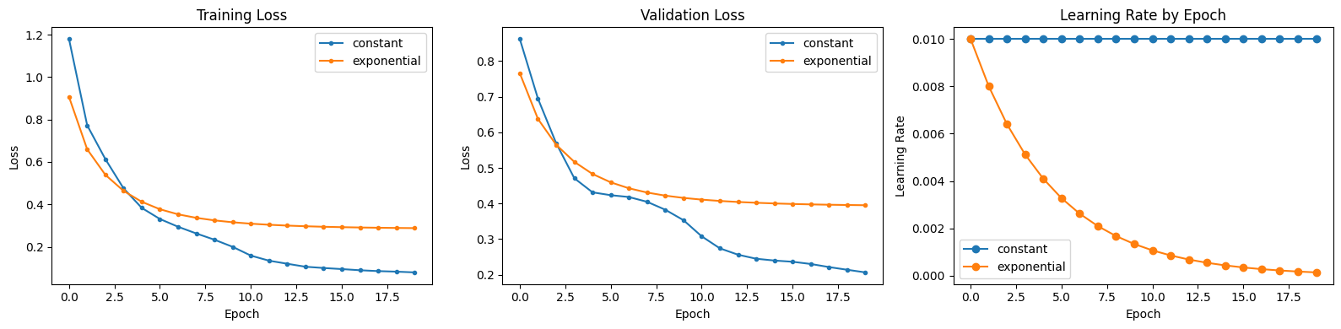
Constant learning rate: the learning rate remains unchanged.
Exponential schedule: the learning rate decreases after each epoch.
Compare validation loss and accuracy to judge which strategy worked better.
Cell 10 — Requirement 4: Compare batch sizes and epoch limits
batch_epoch_results = {}
for batch_size in [8, 32]:
for epochs in [5, 20]:
key = f"Batch {batch_size}, Epochs {epochs}"
batch_epoch_results[key] = train_model(
initializer="he_normal",
batch_size=batch_size,
epochs=epochs
)
batch_epoch_table = []
for key, result in batch_epoch_results.items():
h = result["history"].history
batch_epoch_table.append({
"Experiment": key,
"Epochs Completed": result["epochs_completed"],
"Final Training Accuracy": h["accuracy"][-1],
"Final Validation Accuracy": h["val_accuracy"][-1],
"Final Training Loss": h["loss"][-1],
"Final Validation Loss": h["val_loss"][-1],
"Training Time (seconds)": result["training_time"]
})
batch_epoch_df = pd.DataFrame(batch_epoch_table)
display(batch_epoch_df.round(4))
fig, axes = plt.subplots(1, 2, figsize=(13, 4))
axes[0].bar(batch_epoch_df["Experiment"], batch_epoch_df["Training Time (seconds)"])
axes[0].set_title("Training Time Comparison")
axes[0].set_ylabel("Seconds")
axes[0].tick_params(axis="x", rotation=25)
axes[1].bar(batch_epoch_df["Experiment"], batch_epoch_df["Final Validation Accuracy"])
axes[1].set_title("Final Validation Accuracy")
axes[1].set_ylabel("Accuracy")
axes[1].set_ylim(0, 1.05)
axes[1].tick_params(axis="x", rotation=25)
plt.tight_layout()
plt.show()
print("Compare the measured training times and validation accuracy.")
print("More epochs allow more training, but do not guarantee better generalization.")
print("Training time depends on the hardware and the number of weight updates.")
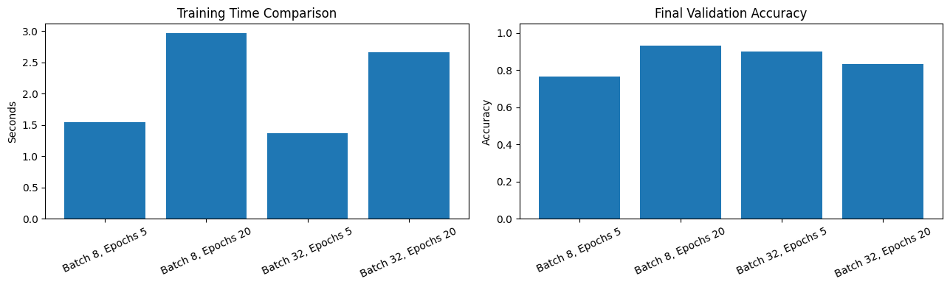
Compare the measured training times and validation accuracy.
More epochs allow more training, but do not guarantee better generalization.
Training time depends on the hardware and the number of weight updates.
Cell 11 — Requirement 5: Investigate regularization and dropout
regularization_results = {}
for name, config in regularization_configs.items():
regularization_results[name] = train_model(
initializer="he_normal",
regularization=config["regularization"],
dropout_rate=config["dropout_rate"],
batch_size=16,
epochs=50,
early_stopping=True
)
regularization_table = []
for name, result in regularization_results.items():
h = result["history"].history
best_index = int(np.argmin(h["val_loss"]))
val_loss, val_accuracy = result["model"].evaluate(X_val, y_val, verbose=0)
regularization_table.append({
"Model": name,
"Epochs Completed": result["epochs_completed"],
"Best Epoch": best_index + 1,
"Best Validation Loss": h["val_loss"][best_index],
"Validation Accuracy at Best Epoch": h["val_accuracy"][best_index],
"Restored Model Validation Loss": val_loss,
"Restored Model Validation Accuracy": val_accuracy,
"Training Time (seconds)": result["training_time"]
})
regularization_df = pd.DataFrame(regularization_table)
display(regularization_df.round(4))
fig, axes = plt.subplots(1, 2, figsize=(13, 5))
for name, result in regularization_results.items():
h = result["history"].history
axes[0].plot(h["loss"], label=f"{name} training")
axes[0].plot(h["val_loss"], linestyle="--", label=f"{name} validation")
axes[1].plot(h["val_accuracy"], label=name)
axes[0].set_title("Training and Validation Loss")
axes[0].set_xlabel("Epoch")
axes[0].set_ylabel("Loss")
axes[0].legend(fontsize=8)
axes[1].set_title("Validation Accuracy")
axes[1].set_xlabel("Epoch")
axes[1].set_ylabel("Accuracy")
axes[1].set_ylim(0, 1.05)
axes[1].legend()
plt.tight_layout()
plt.show()
print("Early stopping monitors validation loss and restores the best weights.")
print("Best epoch is the epoch with the lowest recorded validation loss.")
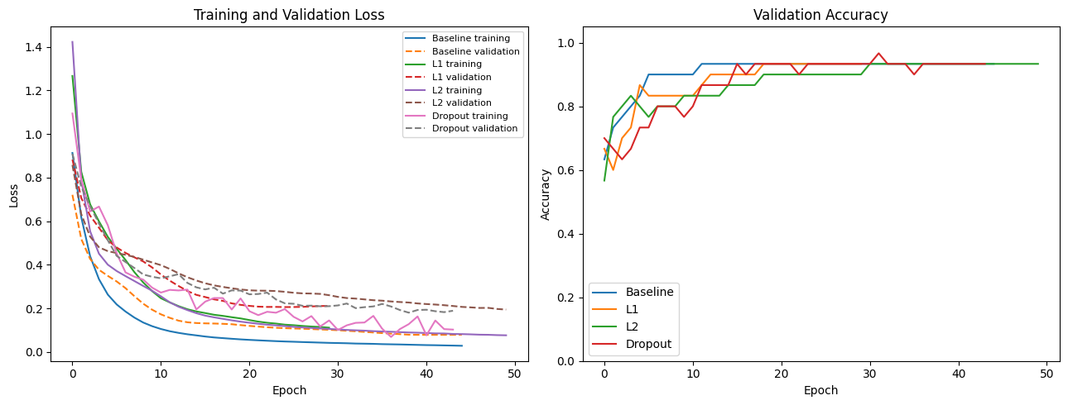
Early stopping monitors validation loss and restores the best weights.
Best epoch is the epoch with the lowest recorded validation loss.
Cell 12 — Requirement 6: Analyze learning curves and select a model
best_name = regularization_df.sort_values("Best Validation Loss").iloc[0]["Model"]
best_result = regularization_results[best_name]
best_model = best_result["model"]
test_loss, test_accuracy = best_model.evaluate(X_test, y_test, verbose=0)
y_prob = best_model.predict(X_test, verbose=0)
y_pred = np.argmax(y_prob, axis=1)
print("Selected model:", best_name)
print("Test loss:", round(test_loss, 4))
print("Test accuracy:", round(test_accuracy, 4))
print("\nClassification report:")
print(classification_report(y_test, y_pred, target_names=iris.target_names, zero_division=0))
cm = confusion_matrix(y_test, y_pred)
ConfusionMatrixDisplay(
confusion_matrix=cm,
display_labels=iris.target_names
).plot(cmap="Blues", values_format="d")
plt.title("Confusion Matrix on Test Data")
plt.tight_layout()
plt.show()
Selected model: Baseline
Test loss: 0.1553
Test accuracy: 0.9333
Classification report:
precision recall f1-score support
setosa 1.00 1.00 1.00 10
versicolor 0.83 1.00 0.91 10
virginica 1.00 0.80 0.89 10
accuracy 0.93 30
macro avg 0.94 0.93 0.93 30
weighted avg 0.94 0.93 0.93 30
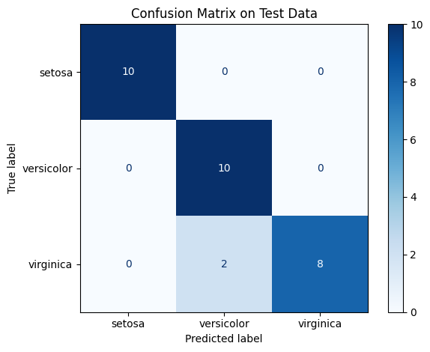
Cell 13 — Final results and observations
final_analysis = []
for name, result in regularization_results.items():
h = result["history"].history
best_index = int(np.argmin(h["val_loss"]))
train_accuracy = h["accuracy"][best_index]
val_accuracy = h["val_accuracy"][best_index]
accuracy_gap = train_accuracy - val_accuracy
if train_accuracy < 0.75 and val_accuracy < 0.75:
interpretation = "Possible underfitting"
elif accuracy_gap > 0.15:
interpretation = "Possible overfitting"
else:
interpretation = "Potentially reasonable fit"
final_analysis.append({
"Model": name,
"Best Epoch": best_index + 1,
"Training Accuracy": train_accuracy,
"Validation Accuracy": val_accuracy,
"Accuracy Gap": accuracy_gap,
"Interpretation": interpretation
})
final_analysis_df = pd.DataFrame(final_analysis)
display(final_analysis_df.round(4))
best_name = regularization_df.sort_values("Best Validation Loss").iloc[0]["Model"]
best_model = regularization_results[best_name]["model"]
test_loss, test_accuracy = best_model.evaluate(X_test, y_test, verbose=0)
print("Selected model:", best_name)
print("Test loss:", round(test_loss, 4))
print("Test accuracy:", round(test_accuracy, 4))
print("Final evaluation used the held-out test set.")
Selected model: Baseline
Test loss: 0.1553
Test accuracy: 0.9333
Final evaluation used the held-out test set.

Task 2: Adaline and Madaline Networks

Part A — Adaline
Cell 1 — Import libraries
import numpy as np
import pandas as pd
import matplotlib.pyplot as plt
np.random.seed(42)
print("NumPy version:", np.__version__)
print("Libraries imported successfully.")
NumPy version: 1.26.4
Libraries imported successfully.
Cell 2 — Create the bipolar AND dataset
X_and = np.array([
[-1, -1],
[-1, 1],
[1, -1],
[1, 1]
], dtype=float)
y_and = np.array([-1, -1, -1, 1], dtype=float)
and_table = pd.DataFrame(X_and, columns=["Input 1", "Input 2"])
and_table["Target"] = y_and.astype(int)
display(and_table)
print("Input shape:", X_and.shape)
print("Target shape:", y_and.shape)
print("Target values:", np.unique(y_and))
Input shape: (4, 2)
Target shape: (4,)
Target values: [-1. 1.]
Cell 3 — Visualize the AND truth table
plt.figure(figsize=(6, 5))
for i, target in enumerate(y_and):
plt.scatter(
X_and[i, 0],
X_and[i, 1],
s=180,
marker="o" if target == 1 else "x",
label=f"Target {int(target)}" if int(target) not in [
int(v) for v in y_and[:i]
] else None
)
plt.text(X_and[i, 0] + 0.08, X_and[i, 1] + 0.05, str(int(target)))
plt.title("Bipolar AND Truth Table")
plt.xlabel("Input 1")
plt.ylabel("Input 2")
plt.xticks([-1, 1])
plt.yticks([-1, 1])
plt.grid(True)
plt.legend()
plt.show()
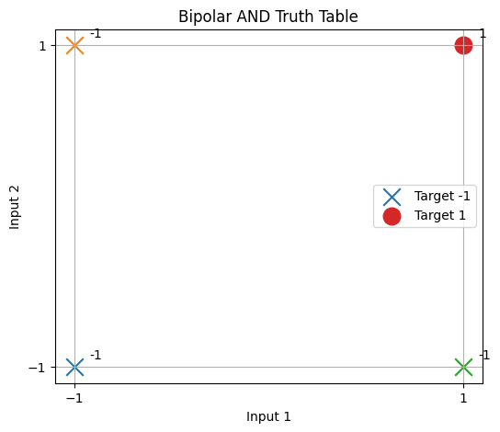
Cell 4 — Implement Adaline using the LMS rule
def fit_adaline(X, y, learning_rate=0.1, epochs=1000):
weights = np.zeros(X.shape[1])
bias = 0.0
mse_history = []
for epoch in range(epochs):
net = X @ weights + bias
errors = y - net
weights += learning_rate * (X.T @ errors) / len(X)
bias += learning_rate * np.mean(errors)
updated_net = X @ weights + bias
mse_history.append(np.mean((y - updated_net) ** 2))
return weights, bias, mse_history
def bipolar_predict(net):
return np.where(net >= 0, 1, -1)
print("Adaline implementation is ready.")
print("Training rule: LMS / delta rule")
print("Training loss: Mean Squared Error")
print("Prediction threshold: net input >= 0 gives +1; otherwise -1")
Adaline implementation is ready.
Training rule: LMS / delta rule
Training loss: Mean Squared Error
Prediction threshold: net input >= 0 gives +1; otherwise -1
Cell 5 — Train Adaline on AND
and_weights, and_bias, and_mse = fit_adaline(
X_and, y_and, learning_rate=0.1, epochs=1000
)
and_net = X_and @ and_weights + and_bias
and_predictions = bipolar_predict(and_net)
and_results = pd.DataFrame({
"Input 1": X_and[:, 0].astype(int),
"Input 2": X_and[:, 1].astype(int),
"Target": y_and.astype(int),
"Net Input": and_net,
"Prediction": and_predictions
})
display(and_results.round(4))
print("Learned weights:", np.round(and_weights, 4))
print("Learned bias:", round(and_bias, 4))
print("Training accuracy:", round(np.mean(and_predictions == y_and) * 100, 2), "%")
Learned weights: [0.5 0.5]
Learned bias: -0.5
Training accuracy: 100.0 %
Cell 6 — Plot MSE by epoch
plt.figure(figsize=(9, 4))
plt.plot(range(1, len(and_mse) + 1), and_mse)
plt.title("Adaline AND: Mean Squared Error by Epoch")
plt.xlabel("Epoch")
plt.ylabel("Mean Squared Error")
plt.grid(True)
plt.show()
print("Initial MSE:", round(and_mse[0], 6))
print("Final MSE:", round(and_mse[-1], 6))
print("MSE decreased:", and_mse[-1] < and_mse[0])
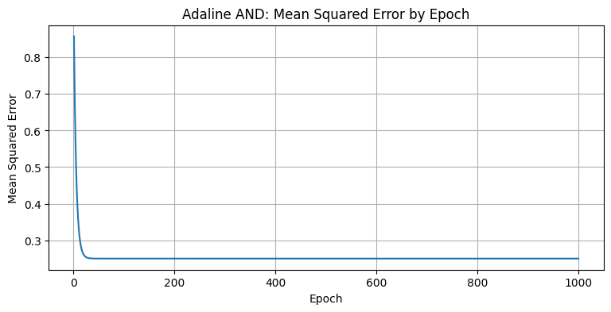
Initial MSE: 0.8575
Final MSE: 0.25
MSE decreased: True
Cell 7 — Show the final AND result
and_results["Correct"] = and_results["Target"] == and_results["Prediction"]
display(and_results)
print("All predictions correct:", bool(and_results["Correct"].all()))
print("Adaline learns a linear decision boundary.")
All predictions correct: True
Adaline learns a linear decision boundary.

Part B — Madaline-style network
Cell 8 — Create the bipolar XOR dataset
X_xor = np.array([
[-1, -1],
[-1, 1],
[1, -1],
[1, 1]
], dtype=float)
y_xor = np.array([-1, 1, 1, -1], dtype=float)
xor_table = pd.DataFrame(X_xor, columns=["Input 1", "Input 2"])
xor_table["Target"] = y_xor.astype(int)
display(xor_table)
print("Number of input patterns:", len(X_xor))
print("Bipolar targets:", y_xor.astype(int))
Number of input patterns: 4
Bipolar targets: [-1 1 1 -1]
Cell 9 — Visualize XOR
plt.figure(figsize=(6, 5))
for i, target in enumerate(y_xor):
plt.scatter(
X_xor[i, 0],
X_xor[i, 1],
s=180,
marker="o" if target == 1 else "x"
)
plt.text(X_xor[i, 0] + 0.08, X_xor[i, 1] + 0.05, str(int(target)))
plt.title("Bipolar XOR Truth Table")
plt.xlabel("Input 1")
plt.ylabel("Input 2")
plt.xticks([-1, 1])
plt.yticks([-1, 1])
plt.grid(True)
plt.show()
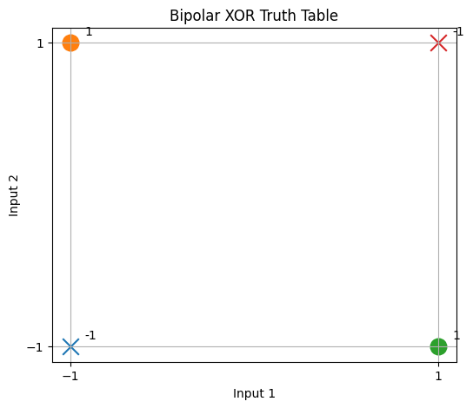
Cell 10 — Train the hidden Adaline units and output unit
hidden_targets = np.array([
[-1, 1, 1, 1],
[1, 1, 1, -1]
], dtype=float)
hidden_weights = []
hidden_biases = []
hidden_mse = []
for targets in hidden_targets:
weights, bias, mse = fit_adaline(
X_xor, targets, learning_rate=0.1, epochs=1000
)
hidden_weights.append(weights)
hidden_biases.append(bias)
hidden_mse.append(mse)
hidden_weights = np.array(hidden_weights)
hidden_biases = np.array(hidden_biases)
hidden_net = X_xor @ hidden_weights.T + hidden_biases
hidden_output = bipolar_predict(hidden_net)
output_weights, output_bias, output_mse = fit_adaline(
hidden_output, y_xor, learning_rate=0.1, epochs=1000
)
output_net = hidden_output @ output_weights + output_bias
xor_predictions = bipolar_predict(output_net)
print("Hidden layer weights:")
print(np.round(hidden_weights, 4))
print("\nHidden layer biases:")
print(np.round(hidden_biases, 4))
print("\nOutput layer weights:")
print(np.round(output_weights, 4))
print("Output layer bias:", round(output_bias, 4))
Hidden layer weights:
[[ 0.5 0.5]
[-0.5 -0.5]]
Hidden layer biases:
[0.5 0.5]
Output layer weights:
[1. 1.]
Output layer bias: -1.0
Cell 11 — Display hidden-unit outputs and XOR predictions
madaline_results = pd.DataFrame({
"Input 1": X_xor[:, 0].astype(int),
"Input 2": X_xor[:, 1].astype(int),
"Target": y_xor.astype(int),
"Hidden Unit 1": hidden_output[:, 0],
"Hidden Unit 2": hidden_output[:, 1],
"Output Net": output_net,
"Prediction": xor_predictions
})
madaline_results["Correct"] = (
madaline_results["Target"] == madaline_results["Prediction"]
)
display(madaline_results.round(4))
print("XOR training accuracy:",
round(np.mean(xor_predictions == y_xor) * 100, 2), "%")
print("All XOR predictions correct:",
bool(madaline_results["Correct"].all()))
XOR training accuracy: 100.0 %
All XOR predictions correct: True
Cell 12 — Plot the training errors
fig, axes = plt.subplots(1, 2, figsize=(12, 4))
axes[0].plot(hidden_mse[0], label="Hidden Unit 1: OR")
axes[0].plot(hidden_mse[1], label="Hidden Unit 2: NAND")
axes[0].set_title("Hidden Adaline Units: MSE")
axes[0].set_xlabel("Epoch")
axes[0].set_ylabel("MSE")
axes[0].legend()
axes[1].plot(output_mse)
axes[1].set_title("Output Adaline: XOR MSE")
axes[1].set_xlabel("Epoch")
axes[1].set_ylabel("MSE")
plt.tight_layout()
plt.show()
print("Hidden unit 1 final MSE:", round(hidden_mse[0][-1], 6))
print("Hidden unit 2 final MSE:", round(hidden_mse[1][-1], 6))
print("Output unit final MSE:", round(output_mse[-1], 6))
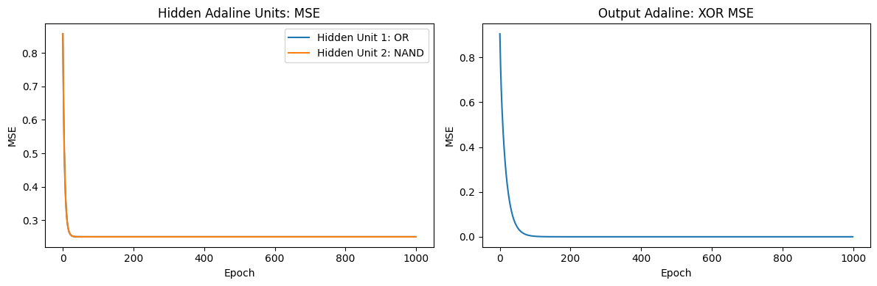
Hidden unit 1 final MSE: 0.25
Hidden unit 2 final MSE: 0.25
Output unit final MSE: 0.0
Cell 13 — Demonstrate why a single Adaline cannot solve XOR
single_weights, single_bias, single_mse = fit_adaline(
X_xor, y_xor, learning_rate=0.1, epochs=1000
)
single_net = X_xor @ single_weights + single_bias
single_predictions = bipolar_predict(single_net)
comparison = pd.DataFrame({
"Input 1": X_xor[:, 0].astype(int),
"Input 2": X_xor[:, 1].astype(int),
"Target": y_xor.astype(int),
"Single Adaline": single_predictions,
"Madaline-style Network": xor_predictions
})
comparison["Single Correct"] = (
comparison["Target"] == comparison["Single Adaline"]
)
comparison["Madaline Correct"] = (
comparison["Target"] == comparison["Madaline-style Network"]
)
display(comparison)
print("Single Adaline accuracy:",
round(np.mean(single_predictions == y_xor) * 100, 2), "%")
print("Madaline-style accuracy:",
round(np.mean(xor_predictions == y_xor) * 100, 2), "%")
print("Single Adaline final MSE:", round(single_mse[-1], 6))
Single Adaline accuracy: 50.0 %
Madaline-style accuracy: 100.0 %
Single Adaline final MSE: 1.0
Cell 14 — Final conclusion for Task 2
print("TASK 2 CONCLUSION")
print("\nPart A: Adaline")
print("Adaline uses a linear net input and the LMS rule to minimize mean squared error.")
print("The sign threshold converts the continuous output into a bipolar prediction.")
print("The AND experiment demonstrates learning a linearly separable classification problem.")
print("\nPart B: Madaline-style Network")
print("Two hidden Adaline units learn OR and NAND, and an output Adaline learns XOR.")
print("The hidden layer transforms the original inputs into a representation that makes XOR linearly separable.")
print("A single Adaline cannot correctly classify all XOR patterns because XOR is not linearly separable.")
print("\nAND accuracy:",
round(np.mean(and_predictions == y_and) * 100, 2), "%")
print("Single Adaline XOR accuracy:",
round(np.mean(single_predictions == y_xor) * 100, 2), "%")
print("Madaline-style XOR accuracy:",
round(np.mean(xor_predictions == y_xor) * 100, 2), "%")
TASK 2 CONCLUSION
Part A: Adaline
Adaline uses a linear net input and the LMS rule to minimize mean squared error.
The sign threshold converts the continuous output into a bipolar prediction.
The AND experiment demonstrates learning a linearly separable classification problem.
Part B: Madaline-style Network
Two hidden Adaline units learn OR and NAND, and an output Adaline learns XOR.
The hidden layer transforms the original inputs into a representation that makes XOR linearly separable.
A single Adaline cannot correctly classify all XOR patterns because XOR is not linearly separable.
AND accuracy: 100.0 %
Single Adaline XOR accuracy: 50.0 %
Madaline-style XOR accuracy: 100.0 %

Task 3 — Pattern Association and Associative Memory
Cell 1 — Import libraries
import numpy as np
import pandas as pd
import matplotlib.pyplot as plt
print("NumPy version:", np.__version__)
print("Libraries imported successfully.")
NumPy version: 1.26.4
Libraries imported successfully.
Cell 2 — Create three input-output pairs
hetero_inputs = np.array([
[1, -1, 1],
[-1, 1, -1],
[1, 1, -1]
])
hetero_outputs = np.array([
[-1, 1],
[1, 1],
[-1, -1]
])
hetero_table = pd.DataFrame({
"Input Pattern": [str(x.tolist()) for x in hetero_inputs],
"Associated Output": [str(y.tolist()) for y in hetero_outputs]
})
display(hetero_table)
print("Number of stored pairs:", len(hetero_inputs))
print("Input pattern length:", hetero_inputs.shape[1])
print("Output pattern length:", hetero_outputs.shape[1])
Number of stored pairs: 3
Input pattern length: 3
Output pattern length: 2
Cell 3 — Visualize the stored patterns
fig, axes = plt.subplots(3, 2, figsize=(7, 5))
for i in range(3):
axes[i, 0].imshow(hetero_inputs[i].reshape(1, -1), cmap="coolwarm", vmin=-1, vmax=1, aspect="auto")
axes[i, 0].set_title(f"Input {i + 1}")
axes[i, 0].set_xticks(range(3))
axes[i, 0].set_yticks([])
axes[i, 1].imshow(hetero_outputs[i].reshape(1, -1), cmap="coolwarm", vmin=-1, vmax=1, aspect="auto")
axes[i, 1].set_title(f"Output {i + 1}")
axes[i, 1].set_xticks(range(2))
axes[i, 1].set_yticks([])
plt.tight_layout()
plt.show()
print("Red and blue shades represent bipolar values -1 and +1.")
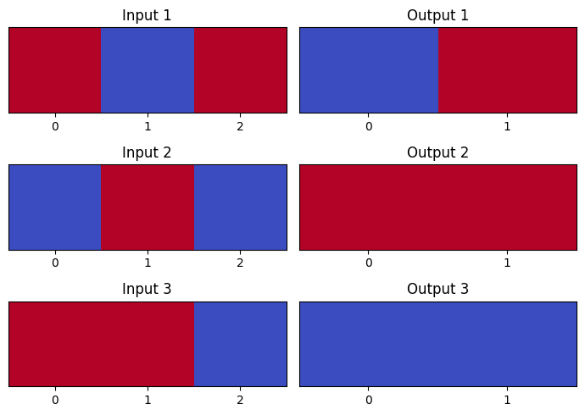
Red and blue shades represent bipolar values -1 and +1.
Cell 4 — Store the associations
hetero_memory = {
tuple(input_pattern): output_pattern.copy()
for input_pattern, output_pattern in zip(hetero_inputs, hetero_outputs)
}
print("Stored associations:", len(hetero_memory))
for input_pattern, output_pattern in hetero_memory.items():
print(list(input_pattern), "->", output_pattern.tolist())
Stored associations: 3
[1, -1, 1] -> [-1, 1]
[-1, 1, -1] -> [1, 1]
[1, 1, -1] -> [-1, -1]
Cell 5 — Test recall for the stored inputs
hetero_results=[]
for i,x in enumerate(hetero_inputs):
recalled=hetero_memory.get(tuple(x))
expected=hetero_outputs[i]
hetero_results.append({
"Input Pattern":x.tolist(),
"Expected Output":expected.tolist(),
"Recalled Output":recalled.tolist() if recalled is not None else None,
"Exact Match":recalled is not None and np.array_equal(recalled,expected)
})
hetero_results_df=pd.DataFrame(hetero_results)
display(hetero_results_df)
print(f"Successful recalls: {hetero_results_df['Exact Match'].sum()}")
print(f"Total stored pairs: {len(hetero_results_df)}")
print(f"Exact recall accuracy: {hetero_results_df['Exact Match'].mean()*100:.1f}%")
Successful recalls: 3
Total stored pairs: 3
Exact recall accuracy: 100.0%
Cell 6 — Test an unknown input
unknown_input = (-1, -1, -1)
unknown_output = hetero_memory.get(unknown_input)
print("Query input:", list(unknown_input))
print("Recalled output:", unknown_output)
print("Query found:", unknown_output is not None)
Query input: [-1, -1, -1]
Recalled output: None
Query found: False
Cell 7 — Create three bipolar patterns
auto_patterns = np.array([
[1, 1, 1, -1, -1],
[1, -1, -1, 1, -1],
[-1, 1, -1, -1, 1]
])
auto_table = pd.DataFrame(
auto_patterns,
columns=[f"Bit {i + 1}" for i in range(auto_patterns.shape[1])]
)
auto_table.insert(0, "Pattern", [f"P{i + 1}" for i in range(len(auto_patterns))])
display(auto_table)
print("Number of stored patterns:", len(auto_patterns))
print("Pattern length:", auto_patterns.shape[1])
print("Unique patterns:", len(np.unique(auto_patterns, axis=0)))
Number of stored patterns: 3
Pattern length: 5
Unique patterns: 3
Cell 8 — Visualize the patterns
plt.figure(figsize=(8, 3))
plt.imshow(auto_patterns, cmap="coolwarm", vmin=-1, vmax=1, aspect="auto")
plt.xticks(range(auto_patterns.shape[1]), [f"Bit {i + 1}" for i in range(auto_patterns.shape[1])])
plt.yticks(range(len(auto_patterns)), [f"P{i + 1}" for i in range(len(auto_patterns))])
plt.title("Stored Autoassociative Patterns")
plt.colorbar(label="Bipolar Value")
plt.show()
print("Each stored pattern should be recalled as itself.")
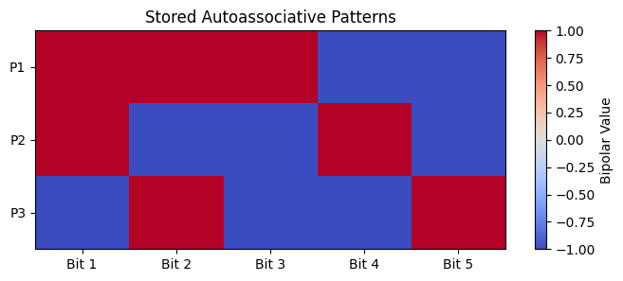
Each stored pattern should be recalled as itself.
Cell 9 — Store patterns and define the recall rule
auto_memory = auto_patterns.copy()
def recall_pattern(query, memory):
distances = np.sum(memory != query, axis=1)
minimum_distance = distances.min()
closest_indices = np.where(distances == minimum_distance)[0]
if len(closest_indices) > 1:
return None, int(minimum_distance), True
return memory[closest_indices[0]].copy(), int(minimum_distance), False
print("Stored patterns:", len(auto_memory))
print("Recall rule: minimum Hamming distance")
print("Tie handling: report ambiguous recall")
Stored patterns: 3
Recall rule: minimum Hamming distance
Tie handling: report ambiguous recall
Cell 10 — Test recall from clean patterns
auto_clean_results=[]
for i,pattern in enumerate(auto_patterns):
recalled,distance,tie=recall_pattern(pattern,auto_memory)
auto_clean_results.append({
"Stored Pattern":pattern.tolist(),
"Query":pattern.tolist(),
"Recalled Output":recalled.tolist() if recalled is not None else None,
"Hamming Distance":distance,
"Tie":tie,
"Exact Match":recalled is not None and np.array_equal(recalled,pattern)
})
auto_clean_df=pd.DataFrame(auto_clean_results)
display(auto_clean_df)
print(f"Clean recall accuracy: {auto_clean_df['Exact Match'].mean()*100:.1f}%")
Clean recall accuracy: 100.0%
Cell 11 — Test recall from corrupted patterns
corrupted_patterns = auto_patterns.copy()
corrupted_patterns[0, 0] *= -1
corrupted_patterns[1, 1] *= -1
corrupted_patterns[2, 4] *= -1
corrupted_results = []
for i, (original, query) in enumerate(zip(auto_patterns, corrupted_patterns)):
recalled, distance, tie = recall_pattern(query, auto_memory)
corrupted_results.append({
"Stored Pattern": f"P{i + 1}",
"Corrupted Query": query.tolist(),
"Bits Flipped": int(np.sum(original != query)),
"Recalled Output": recalled.tolist() if recalled is not None else None,
"Hamming Distance": distance,
"Tie": tie,
"Exact Match": bool(recalled is not None and np.array_equal(recalled, original))
})
corrupted_results_df = pd.DataFrame(corrupted_results)
display(corrupted_results_df)
print("Corrupted recall accuracy:",
round(corrupted_results_df["Exact Match"].mean() * 100, 2), "%")
Corrupted recall accuracy: 100.0 %
Cell 12 — Visualize clean and corrupted recall
fig, axes = plt.subplots(3, 3, figsize=(10, 7))
for i in range(3):
recalled, _, _ = recall_pattern(corrupted_patterns[i], auto_memory)
axes[i, 0].imshow(auto_patterns[i].reshape(1, -1), cmap="coolwarm", vmin=-1, vmax=1, aspect="auto")
axes[i, 0].set_title(f"P{i + 1}: Original")
axes[i, 1].imshow(corrupted_patterns[i].reshape(1, -1), cmap="coolwarm", vmin=-1, vmax=1, aspect="auto")
axes[i, 1].set_title("Corrupted Query")
if recalled is not None:
axes[i, 2].imshow(recalled.reshape(1, -1), cmap="coolwarm", vmin=-1, vmax=1, aspect="auto")
else:
axes[i, 2].text(0.5, 0.5, "Ambiguous", ha="center", va="center")
axes[i, 2].set_title("Recalled Output")
for j in range(3):
axes[i, j].set_xticks(range(5))
axes[i, j].set_yticks([])
plt.tight_layout()
plt.show()
print("Compare each original, corrupted, and recalled pattern.")
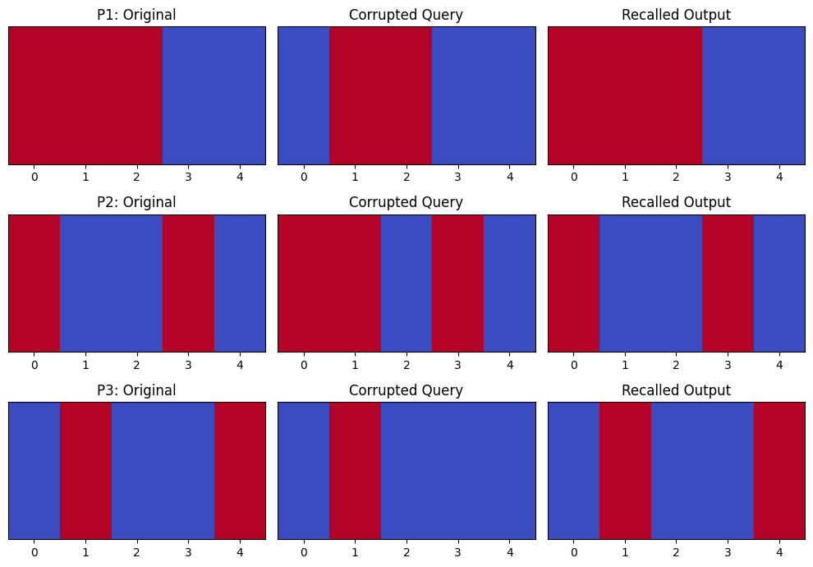
Compare each original, corrupted, and recalled pattern.
Cell 13 — Summarize all recall experiments
summary_results=[]
for i,x in enumerate(hetero_inputs):
recalled=hetero_memory.get(tuple(x))
summary_results.append({
"Memory Type":"Heteroassociative",
"Stored Pattern":x.tolist(),
"Query / Noise":"Clean input",
"Recalled Output":recalled.tolist() if recalled is not None else None,
"Exact Match":recalled is not None and np.array_equal(recalled,hetero_outputs[i])
})
for i,pattern in enumerate(auto_patterns):
recalled,distance,tie=recall_pattern(pattern,auto_memory)
summary_results.append({
"Memory Type":"Autoassociative",
"Stored Pattern":pattern.tolist(),
"Query / Noise":"Clean input",
"Recalled Output":recalled.tolist() if recalled is not None else None,
"Exact Match":recalled is not None and np.array_equal(recalled,pattern)
})
for i,query in enumerate(corrupted_patterns):
recalled,distance,tie=recall_pattern(query,auto_memory)
summary_results.append({
"Memory Type":"Autoassociative",
"Stored Pattern":auto_patterns[i].tolist(),
"Query / Noise":f"One bit flipped: {query.tolist()}",
"Recalled Output":recalled.tolist() if recalled is not None else None,
"Exact Match":recalled is not None and np.array_equal(recalled,auto_patterns[i])
})
summary_df=pd.DataFrame(summary_results)
display(summary_df)
print(f"Total recall tests: {len(summary_df)}")
print(f"Successful exact matches: {summary_df['Exact Match'].sum()}")
print(f"Overall exact-match rate: {summary_df['Exact Match'].mean()*100:.1f}%")
Total recall tests: 9
Successful exact matches: 9
Overall exact-match rate: 100.0%
Cell 14 — Demonstrate a limitation
unknown_input=np.array([-1,-1,-1])
unknown_output=hetero_memory.get(tuple(unknown_input))
unknown_df=pd.DataFrame([{
"Query Input":unknown_input.tolist(),
"Query Found":unknown_output is not None,
"Recalled Output":unknown_output.tolist() if unknown_output is not None else None,
"Exact Match":False
}])
display(unknown_df)
print("Limitation: lookup-based heteroassociative memory only recalls exact stored inputs.")
print("An unknown input has no associated output unless an additional rule is defined.")
Limitation: lookup-based heteroassociative memory only recalls exact stored inputs.
An unknown input has no associated output unless an additional rule is defined.
Cell 15 — Final conclusion for Task 3
print("TASK 3 CONCLUSION")
print("\nHeteroassociative Memory")
print("Stores associations between different input and output patterns.")
print("All stored input-output pairs were recalled using exact lookup.")
print("\nAutoassociative Memory")
print("Stores patterns and recalls the closest stored pattern.")
print("Nearest-pattern recall was tested using clean patterns and one-bit corrupted patterns.")
print("\nLimitation")
print("Lookup-based heteroassociative memory cannot generalize to unseen inputs.")
print("Nearest-pattern autoassociative recall can fail when a query is ambiguous or too far from stored patterns.")
print("\nHeteroassociative exact recall:",
round(hetero_results_df["Exact Match"].mean() * 100, 2), "%")
print("Autoassociative clean recall:",
round(clean_results_df["Exact Match"].mean() * 100, 2), "%")
print("Autoassociative corrupted recall:",
round(corrupted_results_df["Exact Match"].mean() * 100, 2), "%")
TASK 3 CONCLUSION
Heteroassociative Memory
Stores associations between different input and output patterns.
All stored input-output pairs were recalled using exact lookup.
Autoassociative Memory
Stores patterns and recalls the closest stored pattern.
Nearest-pattern recall was tested using clean patterns and one-bit corrupted patterns.
Limitation
Lookup-based heteroassociative memory cannot generalize to unseen inputs.
Nearest-pattern autoassociative recall can fail when a query is ambiguous or too far from stored patterns.
Heteroassociative exact recall: 100.0 %
Autoassociative clean recall: 100.0 %
Autoassociative corrupted recall: 100.0 %

Task 4 — Hopfield Network
Cell 1 — Imports and define patterns
import numpy as np
import pandas as pd
import matplotlib.pyplot as plt
patterns=np.array([
[1,1,1,1,-1,-1,-1,-1],
[1,1,-1,-1,1,1,-1,-1],
[1,-1,1,-1,1,-1,1,-1]
])
print("Number of patterns:",len(patterns))
print("Pattern length:",patterns.shape[1])
print("Unique patterns:",len(np.unique(patterns,axis=0)))
patterns_df=pd.DataFrame(
patterns,
index=[f"P{i+1}" for i in range(len(patterns))],
columns=[f"Bit {i+1}" for i in range(patterns.shape[1])]
)
display(patterns_df)
Number of patterns: 3
Pattern length: 8
Unique patterns: 3
Cell 2 — Calculate the Hebbian weight matrix
N=patterns.shape[1]
weights=patterns.T@patterns/N
np.fill_diagonal(weights,0)
weights_df=pd.DataFrame(
weights,
index=[f"N{i+1}" for i in range(N)],
columns=[f"N{i+1}" for i in range(N)]
)
print("Hopfield Weight Matrix")
display(weights_df)
print("Diagonal weights are all zero:",np.all(np.diag(weights)==0))
print("Weight matrix is symmetric:",np.allclose(weights,weights.T))
Hopfield Weight Matrix
Diagonal weights are all zero: True
Weight matrix is symmetric: True
Cell 3 — Energy function and recall algorithm
def hopfield_energy(state,weights):
return -0.5*state@weights@state
def hopfield_recall(query,weights,max_updates=100):
state=np.array(query,dtype=int).copy()
energy_history=[hopfield_energy(state,weights)]
updates=0
stable=False
while updates<max_updates:
changed=False
for i in range(len(state)):
if updates>=max_updates:
break
net_input=weights[i]@state
if net_input>0:
new_state=1
elif net_input<0:
new_state=-1
else:
new_state=state[i]
if new_state!=state[i]:
state[i]=new_state
changed=True
energy_history.append(hopfield_energy(state,weights))
updates+=1
if not changed:
stable=True
break
return state,energy_history,stable,updates
print("Asynchronous recall function created.")
print("Tie rule: retain the current neuron state.")
print("Maximum updates:",100)
Asynchronous recall function created.
Tie rule: retain the current neuron state.
Maximum updates: 100
Cell 4 — Recall all clean patterns
clean_results=[]
for i,pattern in enumerate(patterns):
recalled,energy_history,stable,updates=hopfield_recall(pattern,weights)
clean_results.append({
"Stored Pattern":f"P{i+1}",
"Input":pattern.tolist(),
"Recalled Output":recalled.tolist(),
"Stable":stable,
"Updates":updates,
"Exact Match":np.array_equal(recalled,pattern)
})
clean_df=pd.DataFrame(clean_results)
display(clean_df)
clean_accuracy=clean_df["Exact Match"].mean()*100
print(f"Clean recall accuracy: {clean_accuracy:.1f}%")
Clean recall accuracy: 100.0%
Cell 5 — Recall with different numbers of flipped bits
rng=np.random.default_rng(42)
corrupted_results=[]
energy_query=None
energy_original=None
for i,pattern in enumerate(patterns):
for bits_flipped in [1,2,3]:
flip_indices=rng.choice(N,size=bits_flipped,replace=False)
query=pattern.copy()
query[flip_indices]*=-1
recalled,energy_history,stable,updates=hopfield_recall(query,weights)
corrupted_results.append({
"Stored Pattern":f"P{i+1}",
"Bits Flipped":bits_flipped,
"Flipped Positions":[int(j+1) for j in sorted(flip_indices)],
"Corrupted Query":query.tolist(),
"Recalled Output":recalled.tolist(),
"Hamming Distance":int(np.sum(recalled!=pattern)),
"Stable":stable,
"Exact Match":bool(np.array_equal(recalled,pattern))
})
if i==0 and bits_flipped==2:
energy_query=query.copy()
energy_original=pattern.copy()
energy_history_sample=energy_history.copy()
energy_recalled=recalled.copy()
corrupted_df=pd.DataFrame(corrupted_results)
display(corrupted_df)
corrupted_accuracy=corrupted_df["Exact Match"].mean()*100
print(f"Corrupted recall success rate: {corrupted_accuracy:.1f}%")
print(f"Successful recalls: {corrupted_df['Exact Match'].sum()} out of {len(corrupted_df)}")
Corrupted recall success rate: 44.4%
Successful recalls: 4 out of 9
Cell 6 — Plot original, corrupted, and recalled patterns
fig,axes=plt.subplots(1,3,figsize=(12,3))
plot_patterns=[
(energy_original,"Original Pattern"),
(energy_query,"Corrupted Pattern"),
(energy_recalled,"Recalled Pattern")
]
for ax,(pattern,title) in zip(axes,plot_patterns):
ax.imshow(pattern.reshape(2,4),cmap="bwr",vmin=-1,vmax=1)
ax.set_title(title)
ax.set_xticks(range(4))
ax.set_yticks(range(2))
for r in range(2):
for c in range(4):
ax.text(c,r,str(pattern.reshape(2,4)[r,c]),ha="center",va="center")
plt.tight_layout()
plt.show()
print("Original:",energy_original.tolist())
print("Corrupted:",energy_query.tolist())
print("Recalled:",energy_recalled.tolist())
print("Exact match:",np.array_equal(energy_original,energy_recalled))
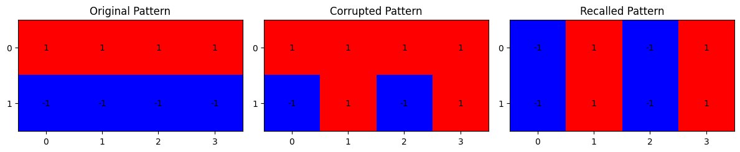
Original: [1, 1, 1, 1, -1, -1, -1, -1]
Corrupted: [1, 1, 1, 1, -1, 1, -1, 1]
Recalled: [-1, 1, -1, 1, -1, 1, -1, 1]
Exact match: False
Cell 7 — Energy during asynchronous updates
plt.figure(figsize=(9,5))
plt.plot(range(len(energy_history_sample)),energy_history_sample,marker="o")
plt.xlabel("Neuron Update")
plt.ylabel("Hopfield Energy")
plt.title("Hopfield Network Energy During Recall")
plt.grid(True)
plt.show()
print("Initial energy:",round(energy_history_sample[0],4))
print("Final energy:",round(energy_history_sample[-1],4))
print("Energy decreased or stayed constant:",all(
energy_history_sample[i+1]<=energy_history_sample[i]+1e-9
for i in range(len(energy_history_sample)-1)
))
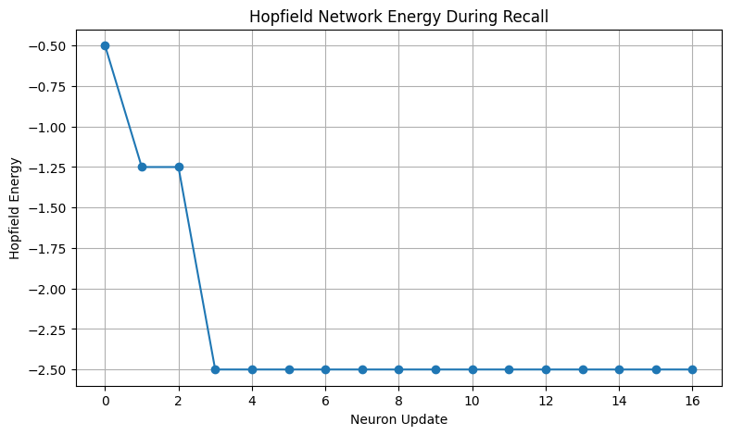
Initial energy: -0.5
Final energy: -2.5
Energy decreased or stayed constant: True
Cell 8 — Show the energy values in a table
energy_df=pd.DataFrame({
"Update":range(len(energy_history_sample)),
"Energy":energy_history_sample
})
display(energy_df.round(4))
Cell 9 — Summary of recall performance
results_summary=pd.DataFrame([
{
"Test":"Clean patterns",
"Successful":int(clean_df["Exact Match"].sum()),
"Total":len(clean_df),
"Success Rate (%)":clean_accuracy
},
{
"Test":"Corrupted patterns",
"Successful":int(corrupted_df["Exact Match"].sum()),
"Total":len(corrupted_df),
"Success Rate (%)":corrupted_accuracy
}
])
display(results_summary.round(2))
print("TASK 4 CONCLUSION")
print("1. Hebbian learning stored three bipolar patterns in a symmetric weight matrix.")
print("2. The diagonal weights were set to zero.")
print("3. Asynchronous recall updated one neuron at a time.")
print("4. A neuron with zero weighted input retained its current state.")
print("5. Energy was tracked during recall.")
print("6. Energy did not increase during asynchronous updates.")
print("7. A stable state is not always the original pattern.")
print(f"Clean recall success rate: {clean_accuracy:.1f}%")
print(f"Corrupted recall success rate: {corrupted_accuracy:.1f}%")
TASK 4 CONCLUSION
1. Hebbian learning stored three bipolar patterns in a symmetric weight matrix.
2. The diagonal weights were set to zero.
3. Asynchronous recall updated one neuron at a time.
4. A neuron with zero weighted input retained its current state.
5. Energy was tracked during recall.
6. Energy did not increase during asynchronous updates.
7. A stable state is not always the original pattern.
Clean recall success rate: 100.0%
Corrupted recall success rate: 44.4%

